Deploy an Application in a VPC with Private Subnet:

Steps:

* **Create a Virtual Private Cloud**:
* Go the VPC dashboard in AWS console.
* Click on the create VPC and select the VPC more.
* Choose the number of availability zones in this case I have chosen 2 availability zones .
* Choose the 2 public subnets and 2 private subnets.
* Choose 1 NAT gateway per availability zone and click on create VPC.
* Go to security groups and click on edit inbound rules add or allow the all traffic rule and ssh port number22 and http port no.80 and click on save changes.

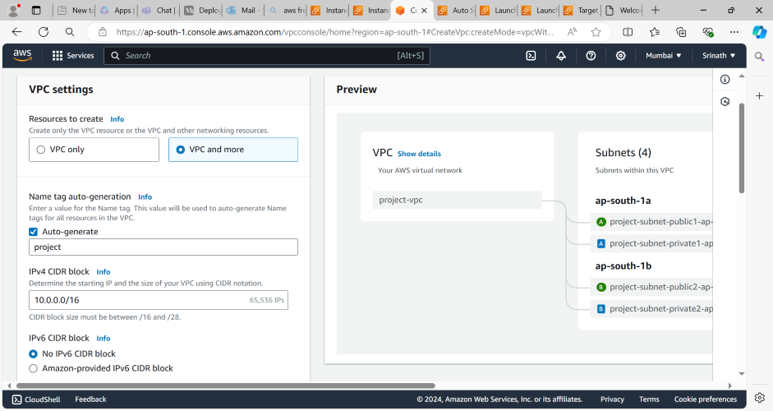

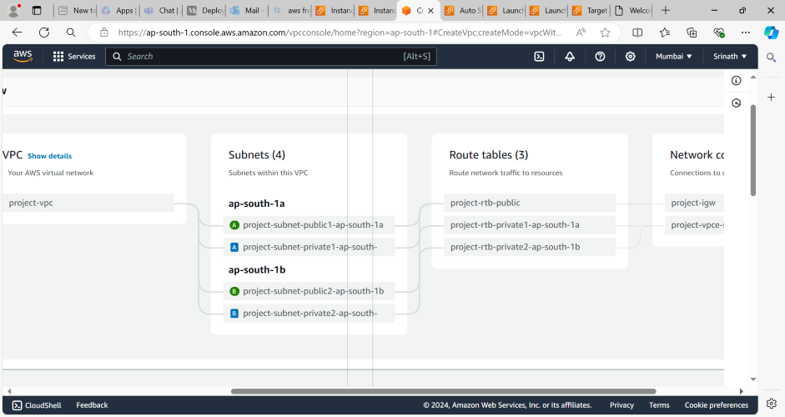

* **Creation of Auto Scaling Group**:
* Go to EC2 dashboard and click on Auto Scaling Groups.
* Click on create auto scaling group and enter the name of auto scaling group.
* Click on create launch template in which we have to specify the ami ,instance type,key pair,security group whatever we want.
* Go to auto scaling group tab select the template whatever I have created and click on next button.
* Select the VPC,two Availability zones with private Subnet click on next.
* Select no laod balancer option and no vpc lattice service and then click on next.
* Specify the desired capacity of group and minimum ,maximum capacity and select no scaling policies click on next.
* Click on next and finally click on create auto scaling group.

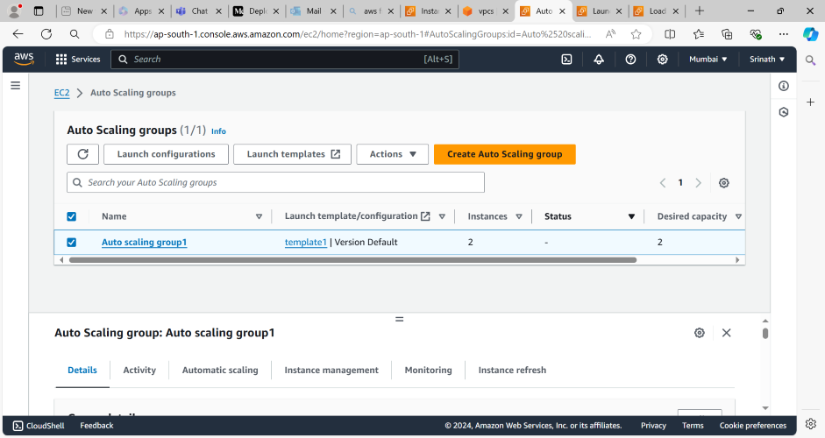

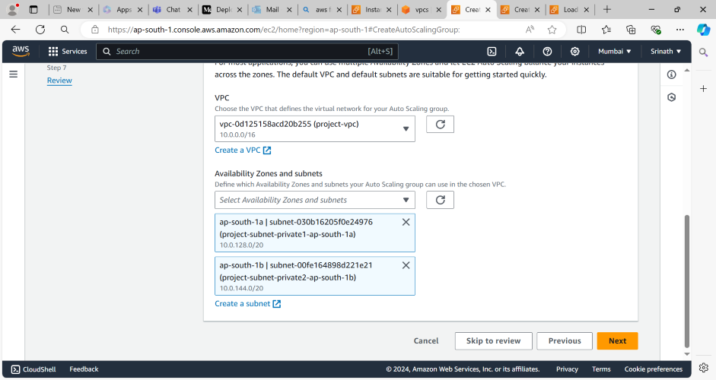

* **Creation of Public instance (Bastion Host):**
* Go to Instance and Click on launch instances.
* Enter the name of instance and choose the ami,instance type,key pair security group and select public subnet.
* In the security group allow all traffic or ssh,http port number.
* Click on launch instance.
* Connect this instance through putty.

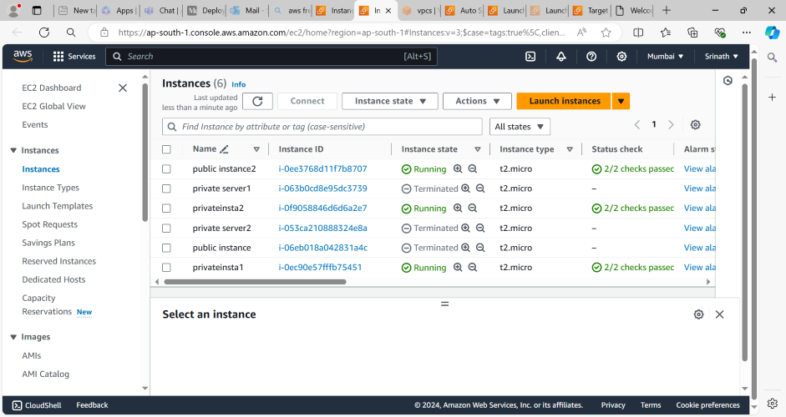

* **Deploy the application on Private servers**:
* From bastion host connect the private servers by using ssh client.
* Copy the pem file and modify the file permission by using chmod command on bastion host.
* Copy this command to access the private server “ssh -i "key pair name" ec2-user@private ip”.
* After connecting to private server install the nginx and start the nginx
* Add or allow security group of load balancer to the private servers of security group after creating load balancer.

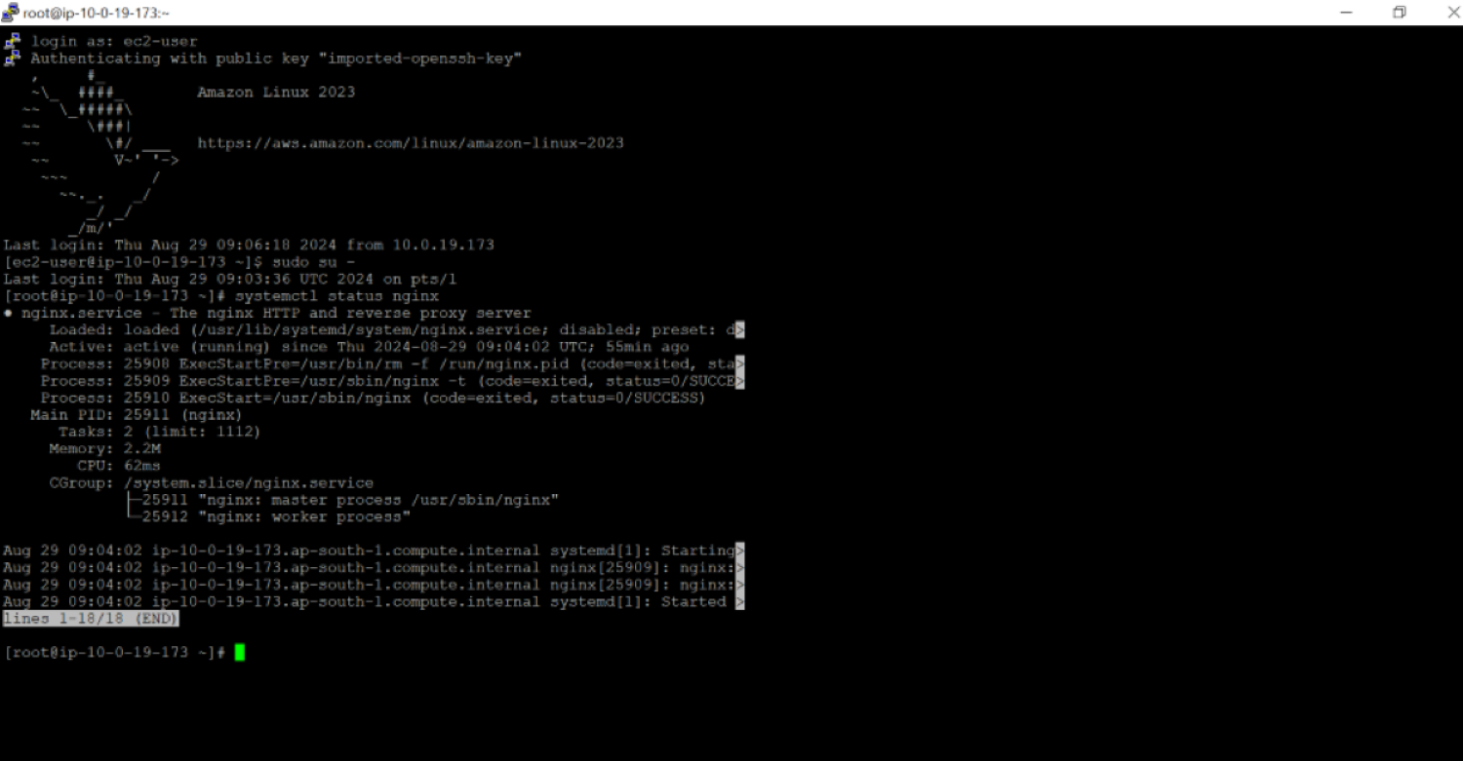

* **Creation of Load Balancer**:
* First Create the target group in which select the instances, specify the name of target group and we can register the servers inside the target group
* After creating target group click on load balancer and select type of load balancer in which I have selected application load balancer.
* Enter the laod balancer name,select the vpc,two availability zones with public subnet and choose security group or create new security group.
* Select target group name whatever I have created earlier and click on create load balancer.
* Configure the health checks of instances in target group.

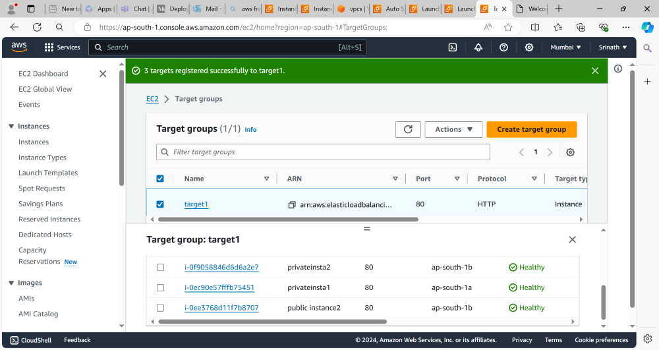

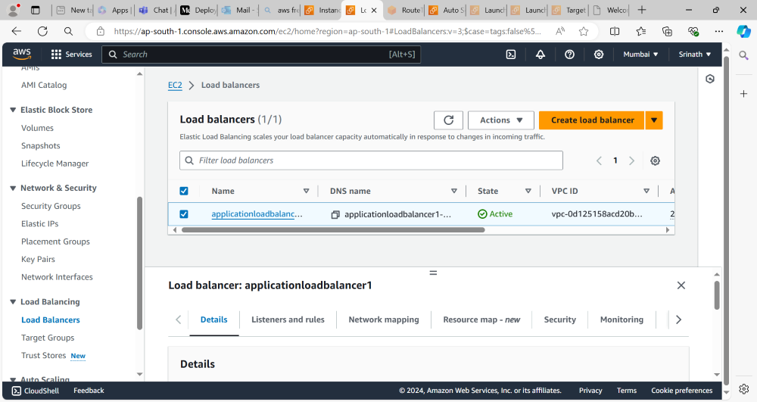

Finally by using load balancer DNS name I can access the application which was deployed on private server.

 